Research-Based Clinical Strategies to Prevent and Address Adolescent Substance Use and Prescription Medication Misuse—Being Part of the Solution
Resources for Parts 1 and 2

The resources in this document complement the information in the NIDA course Clinical Strategies to Prevent and Address Adolescent Substance Use and Prescription Medication Misuse—Being Part of the Solution—Parts 1 & 2.
Quick Links
Click the links below for quick access to the resources in this document:
PART 1
Introduction
- Substance use spectrum
Area 1: Patient Conversations
- Confidentiality and consent
- Conversation starters
- Motivational interviewing training
Area 2: Clinical Assessment
- Preparing for conversations about substance use
- Sample talking points
- Understanding addiction
- Screening tools
- SBIRT resources
- Prescription drug monitoring programs
- Prescribing opioids for chronic pain
- Acute pain management for pediatric patients
- Unused medication disposal instructions
PART 2
Area 3: Preventive Counseling and Addressing Use
- Treatment options
- In-depth assessment tools
- Buprenorphine treatment
Area 4: Follow-Up Practices
- Resources for your patients
- Drug testing
- National surveys
PART 1
Introduction
The following resources expand on what you learned in the Introduction.
Substance Use Spectrum
Review information about diagnosing a substance use disorder
The following table demonstrates how substance use and substance use disorder (SUD) are measured on a spectrum from no use to severe use.
Stage | SUD Diagnosis | Description
No Use  (Abstinence) | NA | No use of drugs or alcohol (more than a few sips counts as use).
Mild Use  (Substance use without a disorder) | NA | Limited use, often during predictable times (e.g., weekends and social situations); no related problems.
Moderate Use | Mild–Moderate SUD | High-risk use resulting in problems (e.g., fighting, criminal offenses, or school suspension) or use to regulate emotions or relieve stress.  Meets 2 to 5 of the Diagnostic and Statistical Manual of Mental Disorders, 5th Edition (DSM-5) criteria for an SUD.
Severe Use | Severe SUD | High-risk use; losing control or an inability to stop using substances.  Meets ≥6 of the DSM-5 criteria for an SUD.

Area 1: Patient Conversations
The resources below expand on what you learned in Area 1, and can help further prepare you for meeting privately with your adolescent patients.

Confidentiality and Consent—What Should You Know?
Get the facts to ensure that you—and your patients—are comfortable discussing sensitive topics

- American Academy of Pediatrics’ Confidentiality Laws Tip Sheet: Reviews the four laws that protect the privacy of patients and health information.

- Confidential Health Care for Adolescents: Position Paper of the Society for Adolescent Medicine and The American Medical Association’s Opinion 5.055 - Confidential Care for Minors: Explains the ethical duty that medical professionals have to respect confidentiality in the delivery of health services for adolescents.

Conversation Starters
Review the HEEADSSS Assessment for additional conversation starters

- HEEADSSS Assessment: Offers a comprehensive list of conversation starters, including questions about home environment, education and employment, eating, peer-related activities, drugs, sexuality, suicide/depression, and safety from injury.

Motivational Interviewing Training
Build your motivational interviewing skills

Many clinicians use motivational interviewing to make the most of substance use discussions with their adolescent patients. Below are some training modules to help you learn this invaluable skill. Please note that practicing motivational interviewing without the proper training is not recommended.

- NIDA’s Blending Initiative Motivational Interviewing CME/CE and Patient Simulation
- American College of Physician’s Motivational Interviewing Module
- MINT’s Motivational Interviewing Training

Area 2: Clinical Assessment
In Area 2, you learned about assessing substance use among adolescent patients by screening patients, talking with them about their substance use, and properly educating them while prescribing a controlled substance. The resources below can bolster the information you learned in those areas.

Preparing for Conversations About Substance Use
Learn more about starting the discussion on substance use with adolescent patients

- Adolescent Substance Use Talking Points: Provides helpful conversation starters and talking points about substance use, confidentiality, positive screening, treatment, and more (see Appendix).
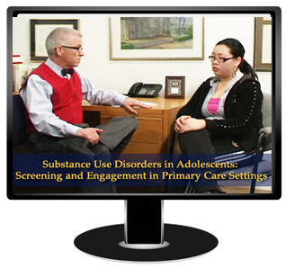
- Substance Use Disorders in Adolescents: Screening and Engagement in Primary Care Settings: Includes video scenarios as guidance for talking with adolescents about their substance use.
- The American College of Physicians’ Addressing Substance Use online module: Presents research on drug abuse, drugs and the brain, and the best strategies for prevention and treatment; includes an adolescent case study.

Understanding Addiction
Find out more about how substance use and addiction affect the brain

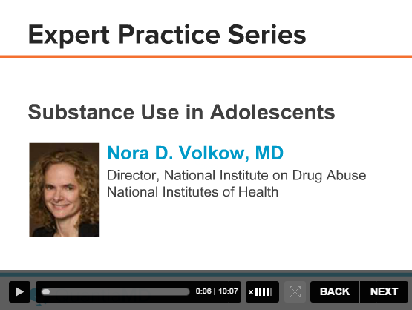
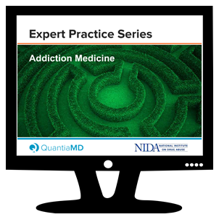
- Substance Use in Adolescents: Features NIDA Director Dr. Nora Volkow presenting on the science of adolescent substance use and the importance of prevention and intervention programs.

- Addiction as a Brain Disease: What Every PCP Should Know About SUDs: Reviews the relationship between addiction and the brain, the mechanisms that perpetuate drug use, and the impact that clinicians can have on substance use.

Which Screening Tool Should I Use?
Select the tool that works best for you and your practice

The following table includes free, validated, adolescent substance use screening tools.

NAME | ADMIN. TIME | ADMIN. METHOD & LINK | VEHICLE | SCREENS FOR | NUMBER OF ITEMS
CRAFFT & CRAFFT Parts A & B | 5 minutes | Self-administered or physician administered | Download/Print | Alcohol & drug use | 9
BSTAD | 5–10 minutes | Physician administered and self-administered | Download/Print or Electronic | Alcohol & drug use; tobacco use | 3
S2BI | 5 minutes | Self-administered or physician administered | Electronic (tablet) | Alcohol & drug use; tobacco use | 3–7
APA Adapted NIDA Modified ASSIST Tools | 5–10 minutes | Self-administered | Download/Print | Alcohol & drug use; other mental health concerns | 25

Substance Use Screening, Brief Intervention, and Referral to Treatment (SBIRT)
Stay up to date on the most recent SBIRT recommendations

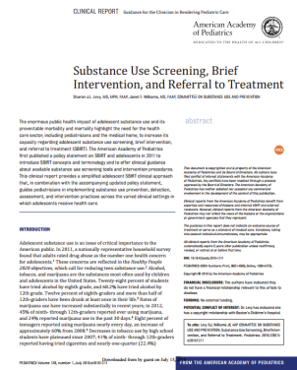
- AAP’s SBIRT Guidelines—Policy Statement and Clinical Report: Provides an adolescent SBIRT approach to guide clinicians in implementing substance use prevention, detection, assessment, referral, and intervention strategies in clinical settings.

- Adolescent SBIRT Toolkit for Providers: Provides helpful advice, compiled by the State of Massachusetts, on referral to treatment, including easy-to-use level of care flowcharts; click the links in the “Downloadables” section to access individual pieces of the toolkit.

Do You Know Your State’s Prescription Drug Monitoring Program (PDMP) Policy?
Get the facts here

- ONDCP PDMP Fact Sheet: Learn more about PDMPs, their effectiveness, and the ways they can be used to address prescription drug misuse.
- Prescription Drug Monitoring Program Training and Technical Assistance Center at Brandeis University: Become familiar with your state’s PDMPs and its rules, statues, and regulations for prescribing controlled substances.

- The Prescription Drug Abuse Policy System Website: Visit this interactive website for additional information on your state’s PDMP policies.

Prescribing Opioids for Chronic Pain
Tackle the current opioid epidemic by safely prescribing opioids

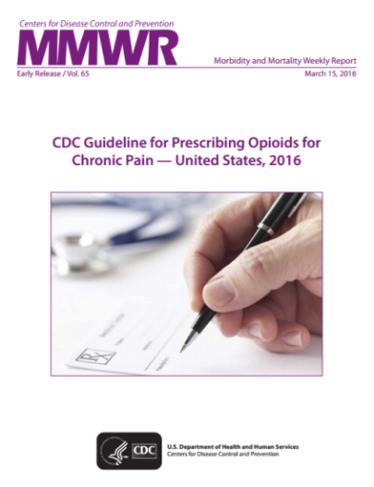
- NIDA’s Opioid and Pain Management Module: Currently, there is little evidence on the benefits and risks of long-term opioid therapy for adolescents. Review this module to understand the severity of the opioid use problem in the United States and to determine ways to prevent medication misuse and abuse.

- CDC’s 2016 Guideline for Prescribing Opioids for Chronic Pain: If you are prescribing opioids for chronic pain to adults, refer to this document for guidance on when to initiate or continue opioid therapy, how to select the right opioid and dosage, and how to assess risks and address harms of opioid use with patients.

Acute Pain Management in Pediatric Patients
Learn more about assessing and treating pain in pediatric patients

- AAP’s Acute Pain Management: Changes and Challenges CME: Complete this module to learn about how to assess and treat pain in children and teens and how to identify patients at risk for misusing opioid medications.

Provide Guidance to Your Patients on Unused Medication Disposal
Explain how to properly dispose of medications

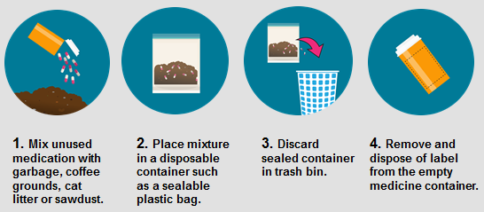
- US Food and Drug Administration’s Guidance on How to Dispose of Medications: Provide your patients with information about how to properly dispose of medications that they no longer need. Taking this step toward reducing the availability of unused medications is one way to combat the prescription opioid epidemic. In addition, some medications can safely be flushed down the sink or toilet. Visit the FDA’s website for the latest list of these medications.

PART 2
Area 3: Preventive Counseling and Addressing Use
In Area 3 we discussed the benefits of early substance use intervention for all of your adolescent patients, regardless of level of substance use. The course also reviewed conversation strategies that you can use during discussions with your patients. The following resources will help you better prepare for discussions about substance use intervention.

Treatment Options for Adolescents
Learn more about adolescent substance use treatment options

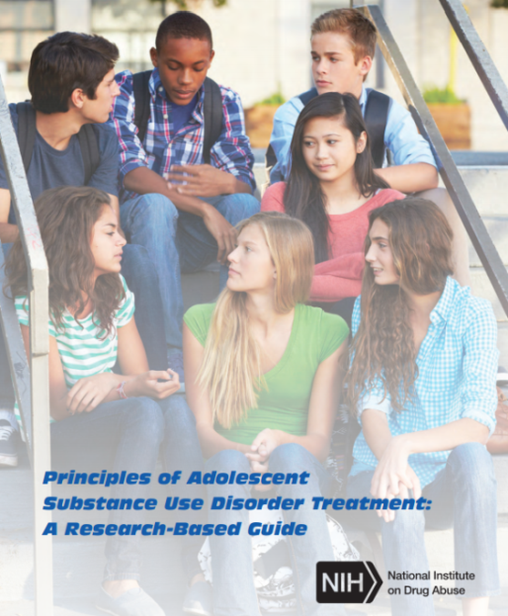
- NIDA’s Principles of Adolescent Substance Use Disorder Treatment: A Research-Based Guide: Use this guide to become familiar with the latest approaches and guiding principles for treating substance use disorders among teens.

- SAMHSA’s Behavioral Health Treatment Services Locator: Use this tool to find nearby treatment services for a patient. Or call 1-800-662-HELP (4357).

- NIDA’s Seeking Drug Abuse Treatment Toolkit: Recommend this toolkit to patients and their caregivers so they can know what to expect from referral to specialty care and how to identify the right treatment programs for their situation.

In-Depth Assessment Tools
Review these tools for in-depth assessment options

- CRAFFT Tool, HEEADSSS Assessment, T-ASI, POSIT: Any of these tools can help you determine the frequency of use and the severity, which will guide next steps for patient care.

Buprenorphine Treatment for Young Adults
Become familiar with the specifics of buprenorphine treatment for teens

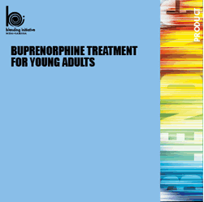
- NIDA/SAMHSA Blending Initiative’s Buprenorphine Treatment for Young Adults training program: Complete this training program to learn about the current rates of nonmedical opioid use, the new research about treating opioid addiction in patients as young as 16 years old, and the latest findings on buprenorphine treatment for young adults.

- SAMHSA’s Buprenorphine Webpage: Review detailed information about buprenorphine and the latest regulations for prescribing it.

- AAP’s MAT Training: Complete this training program to obtain the waiver to prescribe buprenorphine to youth with opioid use disorder.

Area 4: Follow-Up Practices
In Area 4, you reviewed the importance of having follow-up appointments with patients who have reported substance use or for whom you have prescribed a controlled substance. Such appointments—and the resources below—provide you with a unique opportunity to guide a patient in reducing or stopping drug use and leading a healthier life.

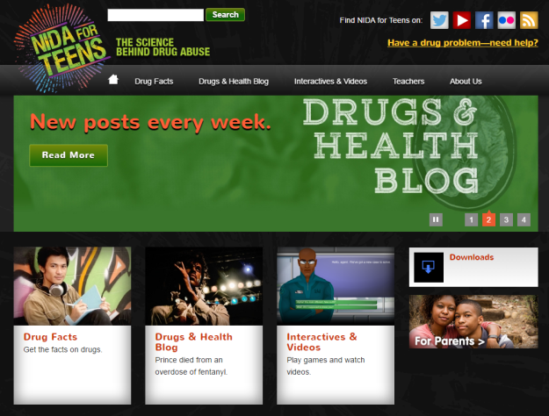
Resources For Your Patients
Tell teens about these resources on substance use

- NIDA for Teens Website: Fuel adolescents’ curiosity with trustworthy facts through their favorite medium—online! Refer them to this site, which can help reinforce your conversations and make your patients more knowledgeable about the effects of drugs.

- NIDA Free Educational Materials: Encourage patients and their parents or caregivers to visit this site for free brochures, posters, articles, and more.

- Drugs, Brains, and Behavior: The Science of Addiction: Provides guidance to help speak to your patients about the effects of drugs on their brains.

Drug Testing
Review the following information before drug testing adolescents

- AAP’s Clinical Report: Testing for Drugs of Abuse in Children and Adolescents: Provides guidance on the efficacy and efficient use of drug testing among children and teens.

- Objective Testing: Urine and Other Drug Tests: Includes helpful information on drug testing, what testing is likely to show, what to ask teens before testing, and which protocols to follow within your clinic.

Stay in the Loop
Check out these national surveys annually to stay current on national drug use trends

- NIDA’s Monitoring the Future Study: Identifies alcohol, tobacco, illegal drug use and abuse, and mental disorders.

- SAMHSA’s National Survey on Drug Use and Health: Identifies adolescent attitudes toward drug, alcohol, and cigarette use and related topics.

- CDC’s Youth Risk Behavior Surveillance System: Examines health-risk behaviors including violence, drug use, sex, unhealthy dietary behaviors, and inadequate physical activity.

If you have any further questions or want to learn more about what you can do to improve the current adolescent substance use trends, please visit the NIDAMED: Medical & Health Professionals website or NIDA’s Twitter feed.

Appendix: Adolescent Substance Use Talking Points
Meeting Privately with Adolescent Patients: Getting Buy-In from Parents and Caregivers
- “As an adolescent, your daughter has a developmental need for more autonomy.”
- “Meeting with your son one on one offers him an opportunity to take ownership of his health and health care, which is also a positive growth experience for him.”
- “Many adolescents will not share information on drug use with parents or caregivers for fear of being judged or punished or causing disappointment.”
- “Your daughter may be more willing to talk with me about possible drug use and its impact on her health if the visit is private.”
- “Overall, your child is healthy, and it’s important that we have an honest exchange about his behaviors because of the potential impact on his health.”
- “Your participation in this process is essential, and I ask that you trust me to include you in the big picture. Let me reassure you that if your daughter is at immediate risk of harm, you will be included in the discussion.”
- “Ultimately, I am in a better position to help your son if I know what health risks are present.”
Discussing Confidentiality with Adolescent Patients
- Reassure patients that conversations are generally private.
  - “I’m so glad that we have an opportunity to talk just one on one.”
  - “I want you to know that I want to keep our conversations private.”
- Be upfront about the limits.
  - “However, my top priority is keeping you healthy.”
  - “If something comes up that causes me to believe that you or others are in immediate danger, I have an obligation to share information with your parents. If I hear that you are at risk of hurting yourself or someone else, or that someone is hurting you, I would have an obligation to help you work that out, which would include sharing the information with your parents.”
- Explain that self-disclosure is an option.
  - “If this should happen, I want you to know that we will talk about it beforehand, and I will give you an opportunity to share it yourself, if you want to.”
  - “Do you have any concerns about talking to your parents about your sensitive topics? If so, what are they?”
Substance Use Conversation Starters
- Start conversations with less sensitive topics and show interest.
  - “What do you like about school this year? What’s frustrating you about this school year?”
  - “What do your classmates do in their free time? What about you and your friends?”
- Project a nonjudgmental attitude.
  - “I see from the results of your screen that you drink alcohol about once a month. Tell me a bit more about that.”
- Use open-ended questions.
  - “There is a lot in the news lately about prescription drugs. What do you think about that?”
  - “You’ve learned about substance use in health class—what do you know about any kids using drugs in your school?”
  - “Why do you think some people about your age have been tempted to use drugs?”
Talking Points for Patients Reporting No Substance Use
- Offer praise and encouragement.
  - “You’ve made a good decision; I’m proud of you.”
- Advise not to start.
  - “I encourage you to stick with that decision. Choosing to stay away from drugs is one of the best things you can do for your health, and also for your performance on the soccer field.”
  - “I think you’ll find that you’ll develop better decision-making skills—and even do better in school—if you don’t drink or use drugs.”
  - “What is something you want to do or learn about, like cooking, writing music, or making your own videos? Taking drugs can get in the way of doing these things.”
- Share additional information.
  - “A lot of teens are confused about the risks of drugs, thinking that it’s not a big deal. But we know now that our brains keep developing into our early 20s, and early substance use can have a long-lasting negative effect on that development.”
Mild Use: Provide Personalized Advice to Quit
- “I know you have your heart set on college, and you’re doing so well in school! I’d really hate to see your concentration and ability to learn affected.”
- “I know sports are important to you. Wouldn’t it be a problem if your stamina or strength were affected, or if you were unable to play on the team because of your use?”
- “I know you love doing [insert patient’s hobby], and you’re so good at it! I’d really hate for anything to interfere with it.”
- “You know, because your brain keeps developing right into your 20s, the earlier you begin to use drugs the more likely they are to cause long-lasting changes in the brain. These changes can lead to addiction and other problems.”
Moderate Use: Negotiate for Positive Change If Unwilling to Quit
- “What are some of the things you think you gain from drinking? I can see how those things are important to you.”
- “I understand it will take time to make these changes, and we can work together to make the process as comfortable as possible. Are you prepared to stop?”
- “If now is not the right time for you, cutting down is a good idea. What are your thoughts about cutting back your drinking alcohol on weekends?”
Responding to Red Flag Behaviors
- “Tell me about what’s going on in your life that has you using marijuana.”
- “I’m sorry that the plan we set for you doesn’t seem to be working. What do you think are the barriers to your cutting back?”
- “Have your family or friends been expressing concerns about your behavior or about possible drug use?”

